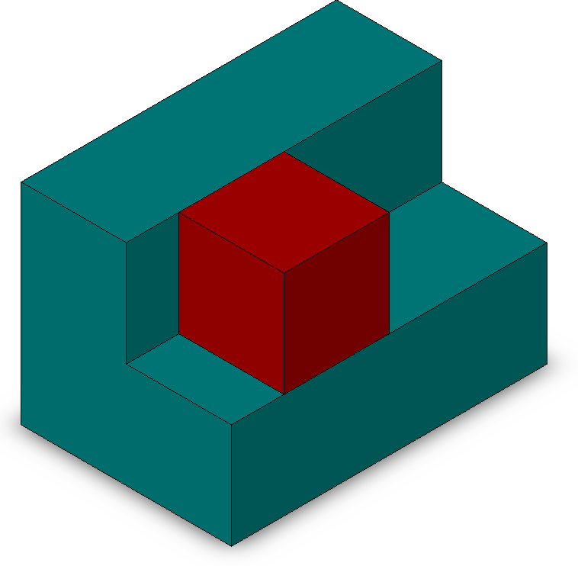
Introduction to Assemblies – Concept Mates

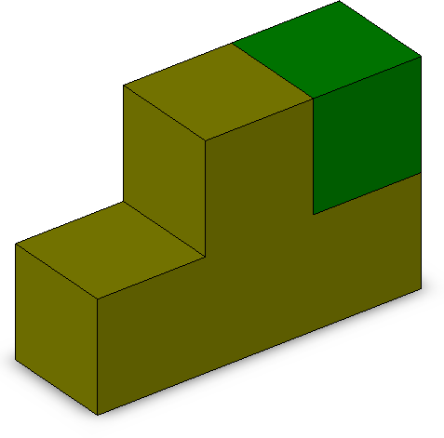
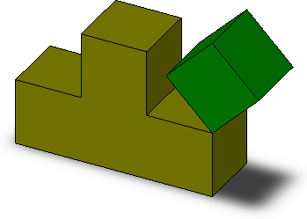
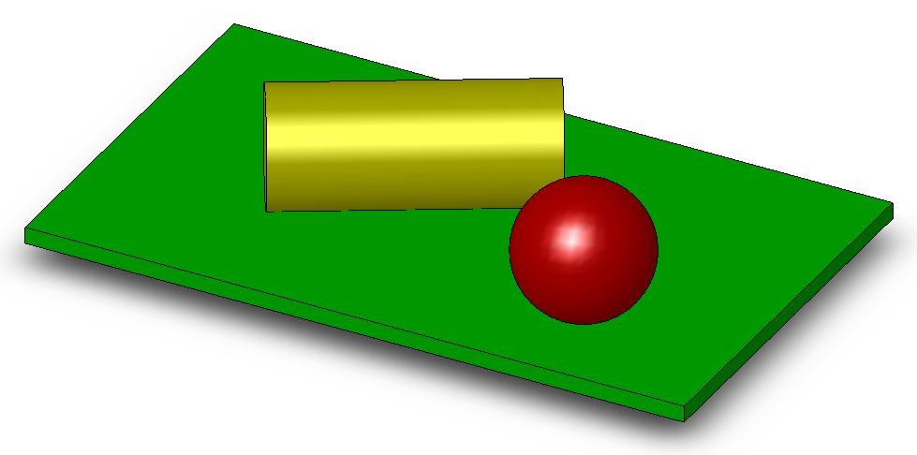
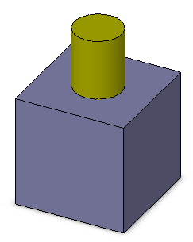
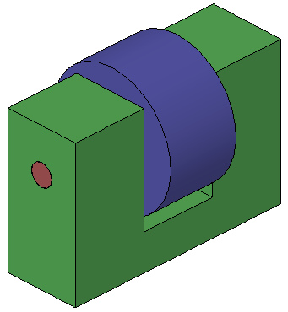
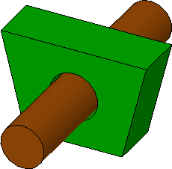
Prerequisite Knowledge To complete this exercise you will need;

- to be familiar with the SolidWorks interface and the key commands.
- basic file management skills
- the ability to rotate views and select faces edges and surfaces.

Focus of the Lesson On completion of this exercise you will have:

Created a number of simple assemblies Saved the assemblies
Added components through browsing Windows Explorer Moved & Rotated Components
Applied Coincident, Concentric, Angled, Tangent and Distance Mates between surfaces and, surfaces and planes.
Fully Defined parts. Deleted Mates

Commands Used Make Assembly from Part/Assembly, Insert Component, Rotate Component, Move Component, Show/Hide Planes, Float, Mate.

Creating an Assembly
Bottom-Up Assembly Bottom–Up Assemblies are created by adding and orientating existing parts in an assembly. Parts added to the assembly appear as Component Parts. Component parts are orientated and positioned in the assembly using Mates. Mates relate faces and edges of component parts to planes and other faces/edges.

Stages in the process Creating a new assembly
New assemblies are created using a similar method as new parts

Adding the first component
Components may be dragged and dropped from an open window or selected from a standard browser.

Position of the first component
The initial component added to an assembly is automatically fixed as it is added. Other components may be repositioned after they are added.

Feature Manager Design Tree and Symbols
The Feature Manager includes many symbols which contain information about the assembly and the components in it.

Mating components to each other
Mates are used to position and orientate components with reference to each other. Mates remove degrees of freedom from the components

Make assembly from Use the Make Assembly from Part/Assembly option to generate a new
Part/Assembly assembly from an open part. The part is used as the first component in the new assembly and is fixed in space.

Where to find it. Click Make Assembly from Part/Assembly on the standard toolbar Or, Select File, Make Assembly from Part
Getting Started The files for this exercise are pre-prepared and located in SolidWorks, Assemblies, Mates on the DCG Day 5 Resource CD

Copy the entire SolidWorks folder from the CD to your hard drive or memory key

Coincident & Angled Mate

Open an existing part Open the part SolidWorks/Assemblies/Mates/Coincident Mates/T Block
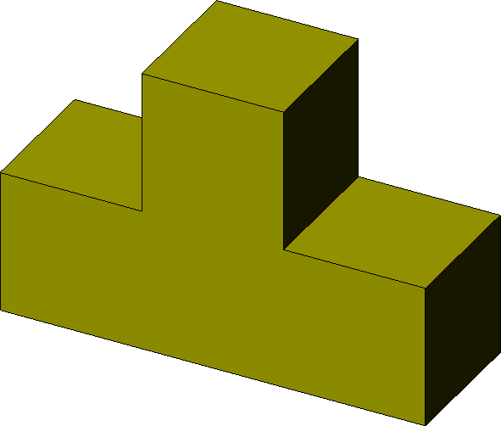
A new assembly will be created using this part

Click Make Assembly from Part/Assembly 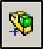
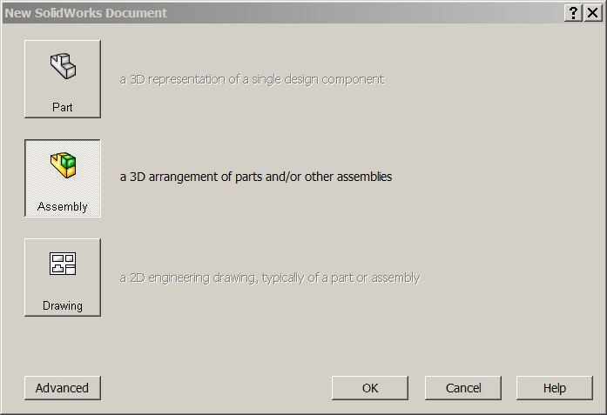
Choose the default assembly template. Click OK

Inserting the first part The Insert Component Dialog box appears with T Block displayed. Expand Thumbnail Preview. Ensure graphics preview is selected.

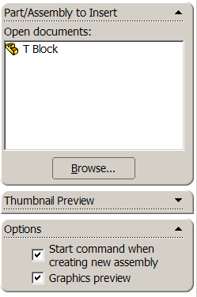
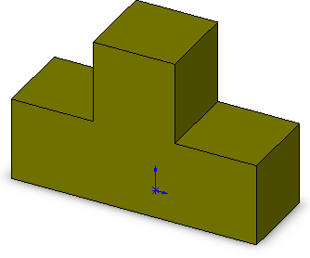
Move the cursor into the drawing area. A transparent preview of the part along with both the part origin and the assembly origin are displayed.

Move the cursor to the origin and select. The part origin will snap to the assembly origin.
If a three dimensional view is not displayed, choose Trimetric View Saving the Assembly Select File, Save as on the standard toolbar.
Save the assembly as Block Assembly into the folder containing the parts used to create it. An assembly is identified by its extension *.sldasm.


Assemblies need to reference the parts used to create them. Should you wish to share an assembly, it is essential that the parts used to create it accompany the assembly. Hence an assembly and its component parts are stored in a folder.

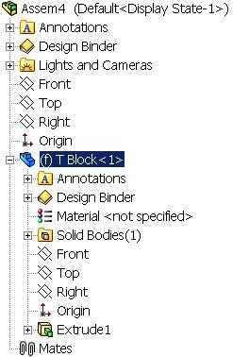
Components Parts that are inserted into the assembly appear
in the Feature Manager Design Tree and may be expanded to show the individual features of that part

State of the Component The part may be fully,
over or under defined. A (+) or (-) sign will precede the part name if it is Over or Under Defined. Parts that are under defined have some degrees of freedom available. Fully defined have none.
Fixed position The (f) preceding T Block indicates that it is fixed in position. Should you try to drag it, it will not move. The first part inserted into an assembly document is fixed by default.

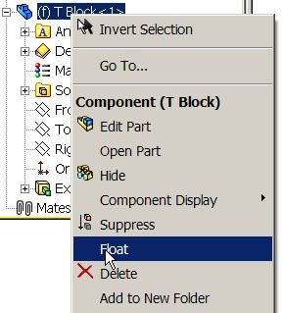
Floating a part Floating a part returns it to an under defined state (-).

To float a part that has been fixed; Right-click the component in the graphics area, or the component’s name in the Feature Manager design tree.

Select Float from the pop-up menu.

Moving Components Holding down the left hand mouse button on the
component will now allow you to move it by dragging. The part is no longer Fixed.
Mates Mates may be used to fully define a component that does not move, or under define a component that is intended to move.

Mates may be added between faces, edges, points, planes etc

Mate Group: All Mates in an assembly are placed in a folder, identified by a double paper clip icon in the feature manager tree.

Insert Mate Insert Mates creates relationships between component parts or between parts and an assembly.

Where to find it. Choose Insert, Mate…
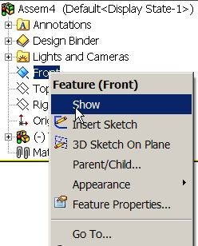
Or Select Mate 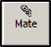 from the Assembly Toolbar
Mating Surfaces and For this exercise we will mate the T Block with the Front,
Planes Right and Top Planes.

Display Planes To begin we must make the 3 planes visible.

Right click on the Front Plane in the Feature Manager design tree and select Show.

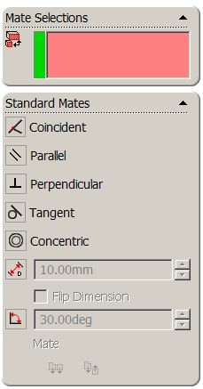
The plane will be visible in the drawing area. Repeat the procedure for the Right & Top Planes.

Command Manager Choose Assemblies from the Command Manager
The Assembly Toolbar is displayed
Adding the Mates Select Mate, 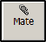 the Mate Property Manager will
appear.
The Mate Property Manager displays the standard mates. Only those suitable for the geometry selected will be available. The remainder will be greyed out.
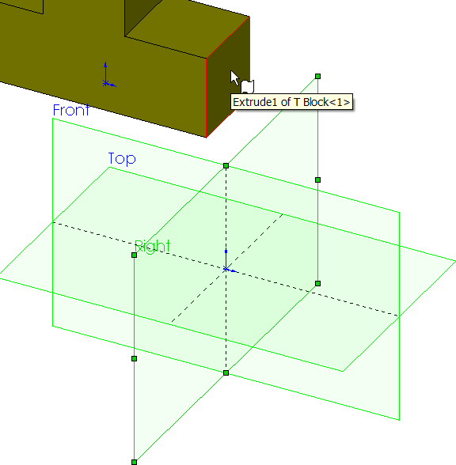
Select the Right Plane and the right face of the block, as shown overleaf.
These will appear in the mate selections
window.
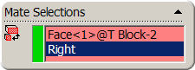

Coincident Mate will be chosen by default and the part will move to enable the face to become coincident with the right plane.
Choose OK 
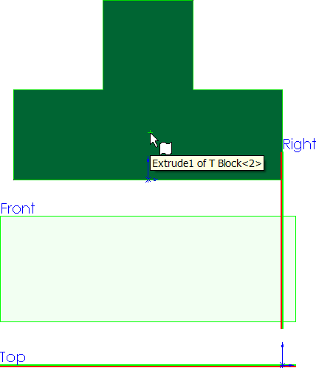
A different mate type may be selected from those available should you so require.

Moving the part Choose Front View

Hold down the left mouse button on the part, and drag.

The part is free to travel vertically but constrained to travel along the
right plane. It has lost some of its

degrees of freedom

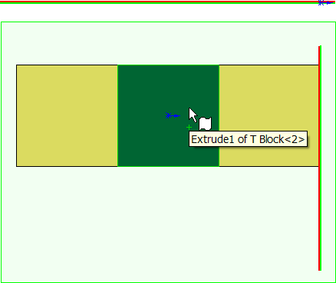
Choose Top View

The part is free to travel horizontally but constrained to travel along the right plane.

Further Constraint. Ensure that no faces are selected
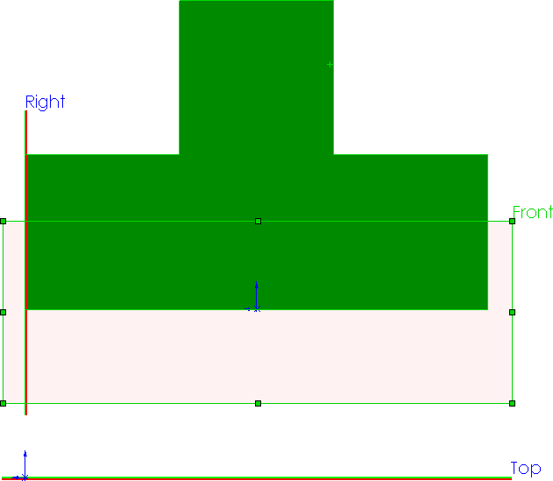
Select Back View.

Choose Mate from the Assembly Toolbar.

Select the Front Plane and the back face as shown.

Coinicident Mate will be chosen by default. Choose OK

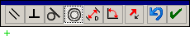
Mate Pop-up Toolbar The Mate Pop-up Toolbar is used to make
selections easier by displaying the available mate types on the screen.
These mirror those that appear in the property manager.

Moving the part Choose Top View

Hold down the left mouse key on the part and drag. The part is no longer free to move in this direction, this degree of freedom has been removed by the coincident mate to the front plane.

Fully Defined In the Feature Manager design tree the minus still precedes the part name.

This indicates that it is not yet fully defined

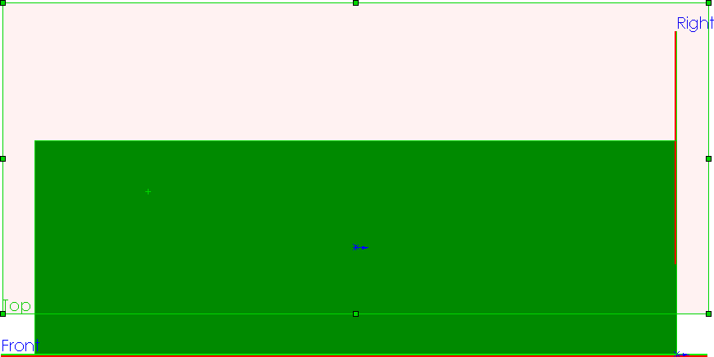
Further Mate Choose Bottom View

Apply a Coincident Mate between the base surface and the Top Plane

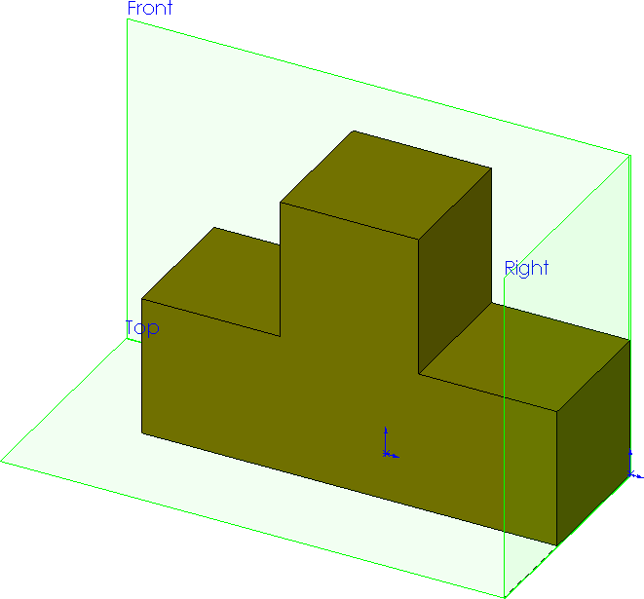
Choose Trimetric View.

The part may no longer be moved by dragging. All degrees of freedom have been removed.
The part is now fully defined

Hiding Planes To Hide a plane, right click on the plane and
choose Hide. Hide all planes.

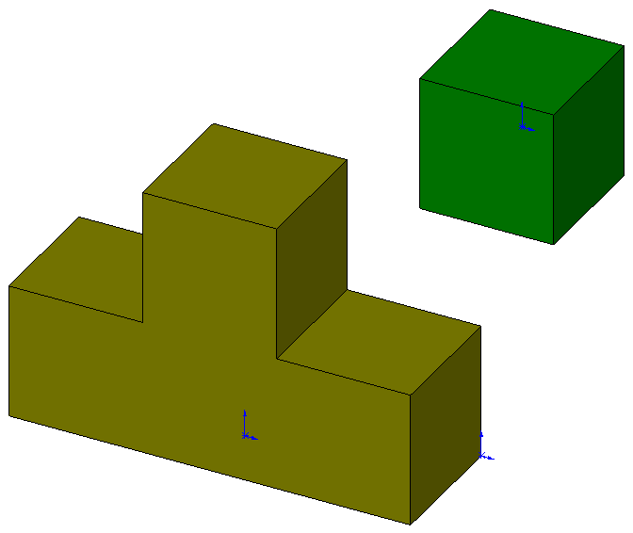
Adding Components Select Insert Component 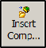 from the Assembly Toolbar
box
Choose Browse from the Insert Component dialog

Choose Square Block from the folder of parts. Choose Open
A preview is displayed in the drawing area. Click to drop it as shown.
This part is not fixed. It is free to move and rotate.
RD5 DCG/Ex1 Design & Communication Graphics 6

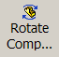
Rotating Components Select Rotate Components from the Assembly Toolbar.

Place the rotate symbol over the component, hold down the left hand mouse button and drag. The component will rotate through its available degrees of freedom.
This is not to be confused with Rotate View 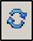 from the View toolbar.
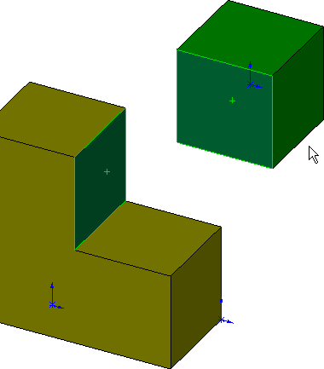
In order to create mates it is essential that we are proficient at rotating views of parts, in order to select faces/edges.
Coincident Mate Select Mate, the Mate Property Manager will
appear

Select the faces shown opposite.
Create a Coincident Mate between the faces

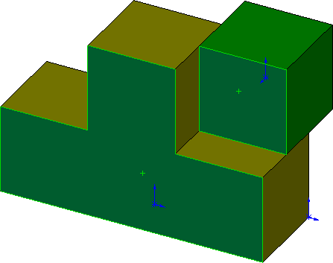
Create a further Coincident Mate between the underside of the block and the top face of the step

Fully Defined The block is still free to slide along the mated faces

To fully define the part a coincident Mate must be added between the faces displayed.
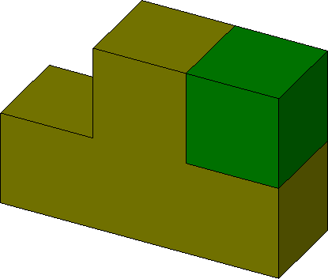
Deleting Mates To delete a mate;
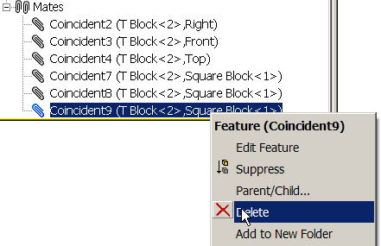
Double Click the paper clip icon in the Feature Manager design tree
All mates within the assembly will be displayed.

Right Click on any mate and select Delete.
This will restore a degree a freedom to the part.

Delete the 3 Coincident Mates between the T Block and the Square Block. The Square Block is free to move through all degrees of freedom again.

Mates between edges A Coincident Mate may also be created between edges
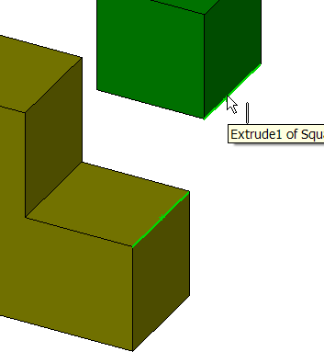
Select Mate, the Mate Property Manager will appear.

Choose the two edges highlighted opposite. Choose Coincident Mate.
Add a further Coincident Mate between the front faces of both blocks.
Choose OK , and OK again.
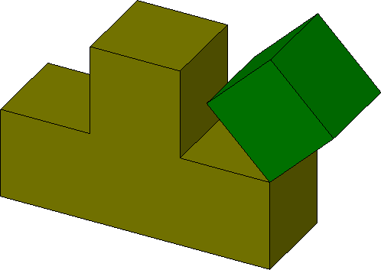
Moving the part Drag the part.

Because of the mates selected the part rotates around the mated edge.

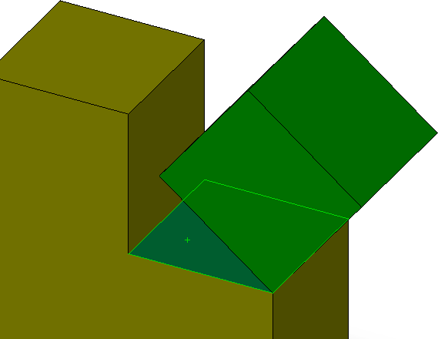
It is not necessary to fully define all components within an assembly. Under defined parts may be used to display motion in an assembly.

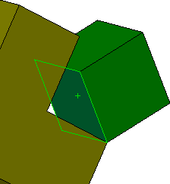
Angled Mate Select Mate.
Choose the surfaces shown opposite.

Coincident Mate is selected by default.

Choose Angled Mate. Input a value of 45º.
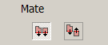
Investigate the use of Aligned/Anti-Aligned
Select OK

Fully Defined Drag the block. The part no longer rotates around the coincident edge. It has no
degree of freedom available. It is fully defined.

Save and Close Save and Close the assembly.

Distance Mate

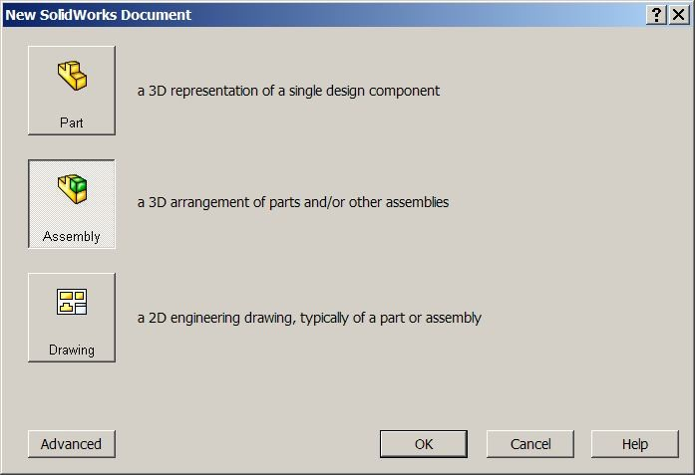
Getting Started Choose File, New…

Select the default assembly. Choose OK
An assembly may be generated by creating a new assembly document from the dialog box shown and then subsequently inserting the first part.

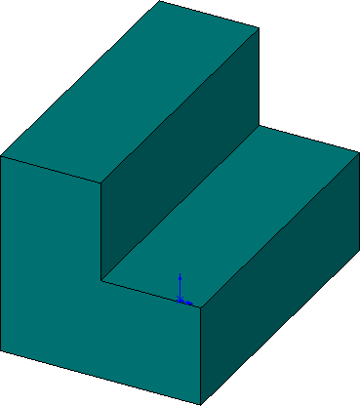
Insert Components Choose Browse from the Insert Component dialog box.

Browse to;

SolidWorks/Assemblies/Mates/Distance Mates
Select the part L Block and drop it fixed to the origin.
Save the Assembly Save the assembly as Distance Mates in the

Distance Mates folder
Further Components Choose Insert Component from the Assemblies Toolbar

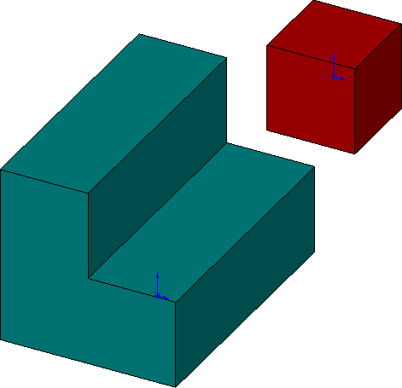
Select Square Block from the Distance Mates folder. Drop it into position as shown.
Concentric Mates Add Concentric Mates between the
vertical and horizontal faces to constrain the square block as shown below.

Degrees of Freedom Drag the block. It still has the freedom to slide
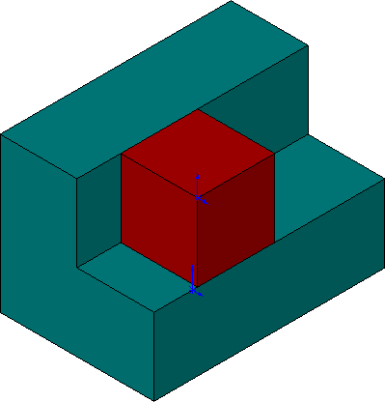
along the faces with which it is mated.

Distance Mate Used to define a distance or gap between parts, faces, edges or points.
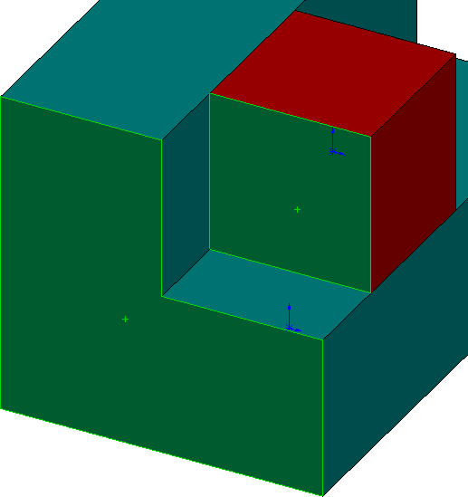
Select Mate

Choosing faces Choose the highlighted faces shown opposite

Choose Distance Mate
Enter a distance value of 30mm
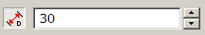
The block will move so that the distances between the faces is 30mm.

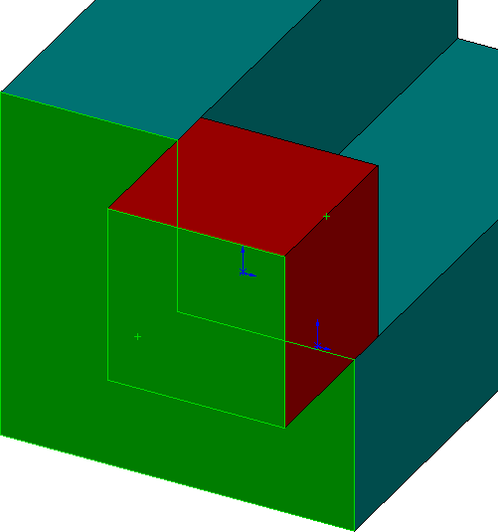
Flip Direction Check Flip Direction to force the faces 30mm
apart in the opposite direction
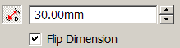

Uncheck Flip Direction
Choose OK , and OK again.

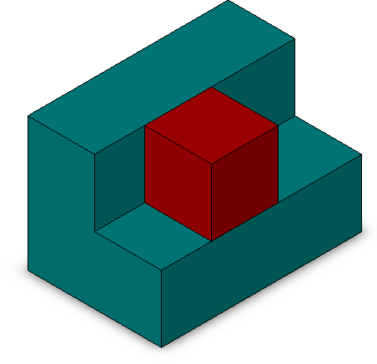
Fully Defined It is no longer possible to drag the part. It is Fully Defined Save & Close Save & Close the assembly.

Concentric Mate
Getting Started Create an assembly using the part Cube located in;

SolidWorks/Assemblies/Mates/ Concentric Mates
Fix the part origin to the assembly origin.

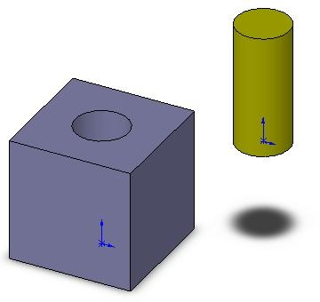
Saving the assembly Save the assembly as Concentric Mates in the Concentric Mates folder.

Insert Components Insert the part Dowel from
the same folder.

Concentric Mates Select Mates
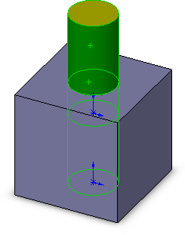
Choose the surface of the dowel and the internal surface of the hole.

Because of the geometry selected, Concentric Mate is displayed by default.
The dowel moves so that its axis coincides with the axis of the hole.
Choose OK
Move the part Drag the part. Because it is under-defined, it will move within its remaining degrees of freedom – vertically along the axis of the hole and dowel.
Fully Defined How would you completely restrict the movement of the dowel?
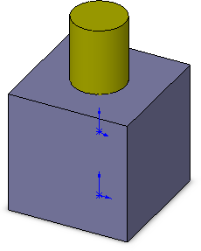

Tangent Mate
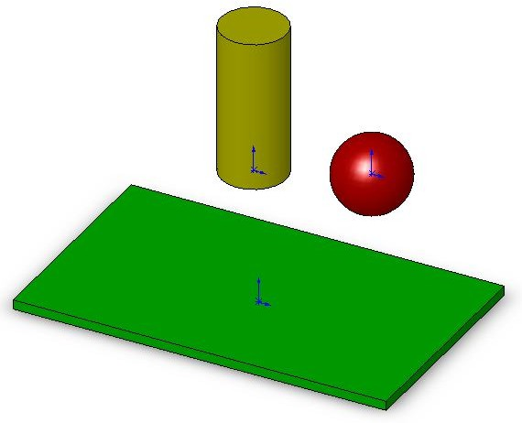
Getting Started Create an assembly using the part Base located in;

SolidWorks/Assemblies/Mates/ Tangent Mates
Fix the part origin to the assembly origin. Saving the assembly Save the assembly as Tangent Mates in the

Tangent Mates folder.

Insert Components Insert the parts Dowel and Ball from
the same folder.

Tangent Mate Tangent Mate is only available when the geometry
selected may be made tangential to one another.

Choose Mate. Choose the top face of the dowel and the top face of the base. Tangential Mate is unavailable - greyed out. Choose X
Choose Mate. Choose the cylindrical face of the dowel and the top face of the base. Tangential Mate is now chosen by default. The dowel moves such that its surface is tangential to the top surface of the base.

Aligned/Anti-Aligned The dowel may be tangential to the underside of the surface.

Toggle between Aligned & Anti-Aligned and note the effect.
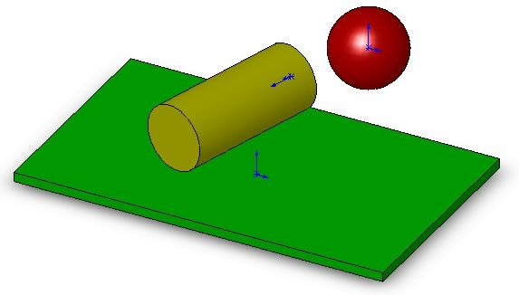

Choose OK

Move the dowel Drag the dowel. The dowel will remain tangentially in contact with a plane containing the top surface at all times.

Further Mates Add a Tangent Mate between the ball and the surface of the base. Investigate the effect of Aligned and Anti-Aligned.
Choose OK

Problem When the ball is dragged against the dowel it intersects it as shown below.
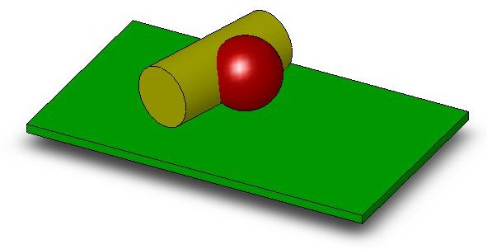
Solution? At this stage, what could we use to solve this problem?

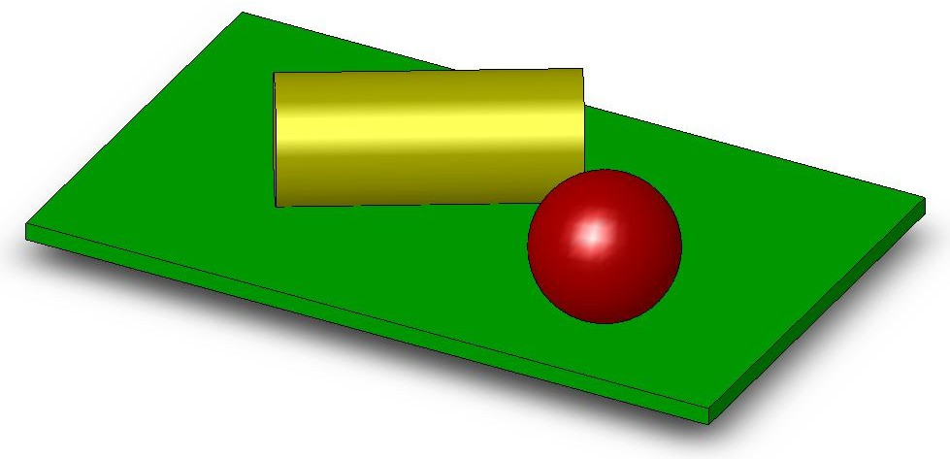

Width Mate
Width Mate A Width Mate centres two tab faces within the width of two reference faces. Getting Started Open the assembly named Width Mate from the folder;

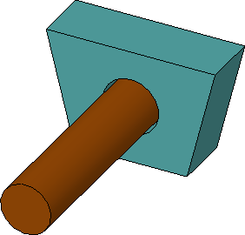
SolidWorks/Assemblies/Mates/ Width Mate
This assembly consists of an axle housing along with an axle. A concentric mate has been added between the axle and the hole. However the axle is still free to travel longitudinally along the hole axis.
The challenge is to centre the housing between the faces of the axle.
Knowing the length of the axle and the width of the housing, distance mate could be used. However, if dimensional changes were made to either part the housing would no longer be centred.

Width Mate Select Mate.
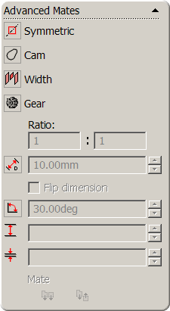
Expand Advanced Mates and select Width Mate.

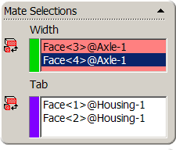
Select the faces of the axle as the Width Selection
Select the faces of the housing as the Tab Selection

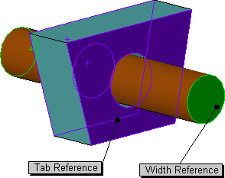
The axle moves such that the housing is centred
on it.

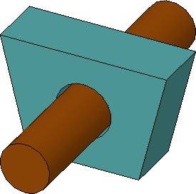
Should any dimensional changes take place the housing will always remain centred on the axle.

Save & Close Save & Close the assembly.
Further Exercise Open the assembly named Width Mate 1 from the folder;

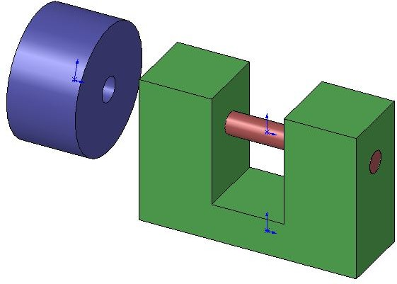
SolidWorks/Assemblies/Mates/ Width Mate1
A concentric mate has been applied between the sleeve and the swivel bar. The sleeve is still free to travel along the axis of the bar.

We wish to constrain the sleeve such that it is centred between the internal faces of the U Bar. This will be achieved by adding a Width Mate.
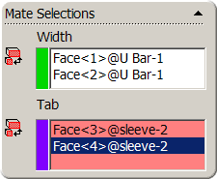
Width Mate Select Mate. Choose Width Mate.

Select the internal faces of the U Bar as the Width Selection

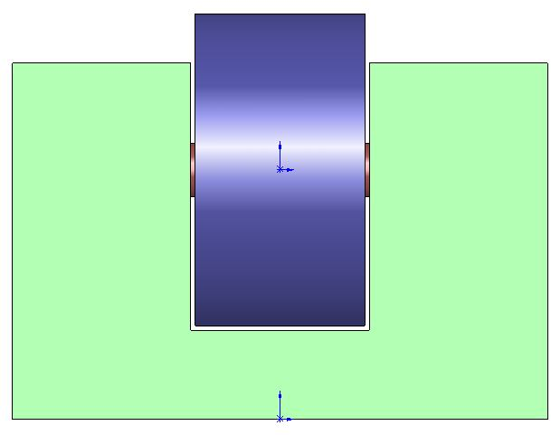
Select the faces of the Sleeve as the Tab Selection
The sleeve will move to a position, centred between the two internal faces of the U Bar.

Drag the part Drag the sleeve, it is still free to rotate around the swivel bar. It is not fully defined.

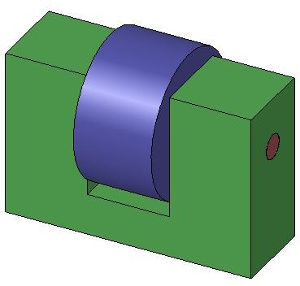

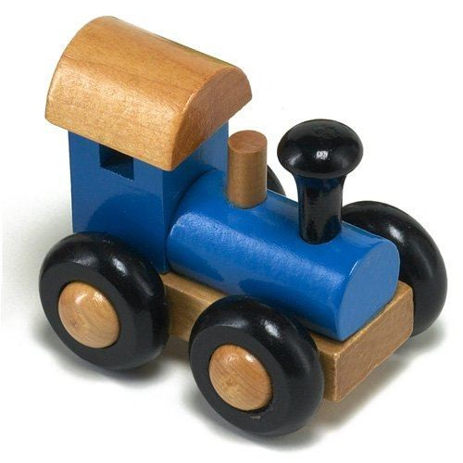
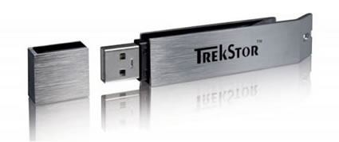
Assemblies

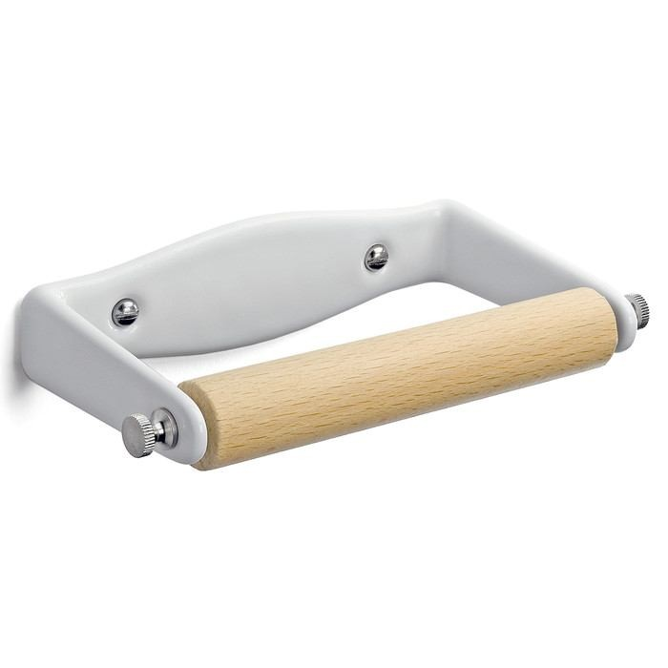
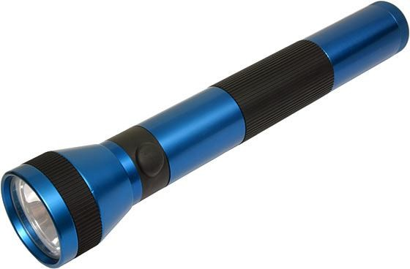
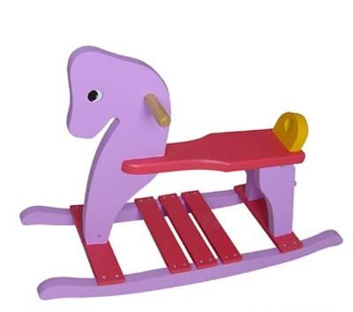
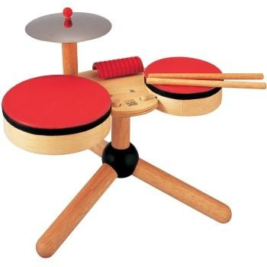

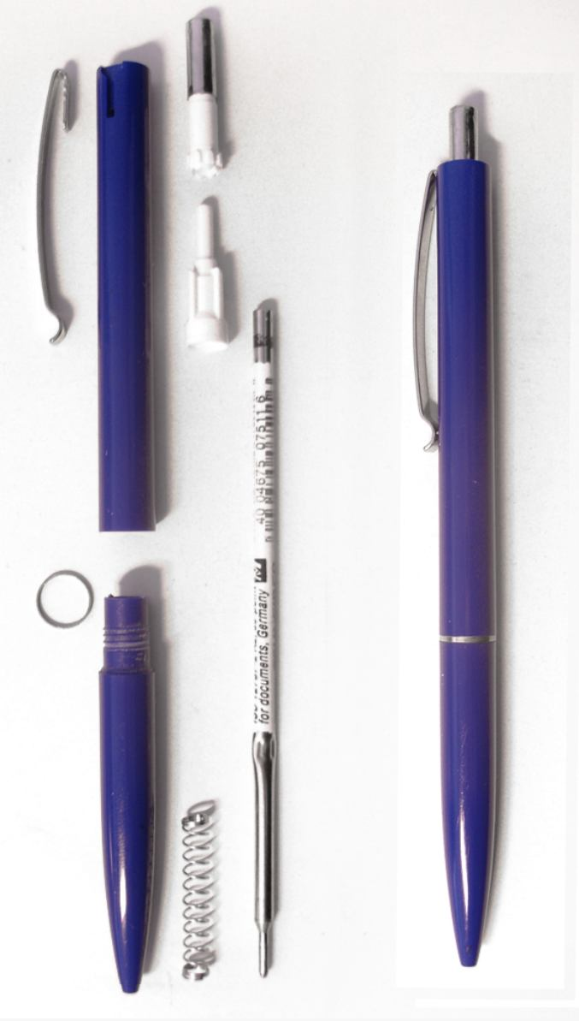

DESIGN & COMMUNICATION GRAPHICS

NAME: DATE:

